Decision-Making Style
Style | Focus | Tolerance for Ambiguity | Key Characteristics | Strengths | Example
Directive | Task-oriented | Low | Quick, decisive, relies on own knowledge, minimal input | Effective in urgent situations | A CEO decides on matching employee 401(k) contributions based on budget projections for attracting talent.
Analytical | Task-oriented | High | Thorough data analysis, considers many options | Suited for complex decisions | A marketing manager uses demographic data analysis to optimize an ad campaign's reach, deciding to increase social media ad space.
Conceptual | Social-oriented | High | Big-picture thinking, open to risks, considers long-term impacts | Ideal for strategic planning and innovation | A start-up founder plans for national expansion, deciding to open a new store in a promising location despite risks, aiming for long-term brand establishment.
Behavioural | Social-oriented | Low | Prioritizes relationships, seeks team consensus | Maintains team alignment and morale | An HR manager chooses bonus vacation days based on employee preferences, ensuring team satisfaction and addressing any concerns.
Method | Description | When to Use | Example
Command Decision-Making | Decisions made without input from others, relying on one's own knowledge. | In time-sensitive or fast-paced environments. | A production floor manager assigns tasks independently to maintain workflow.
Collaborative Decision-Making | Group discussions to reach a decision, considering multiple perspectives. | When diverse perspectives can enhance decision quality. | A marketing team collaborates on a social media campaign, incorporating feedback from various sources.
Consensus-Based Decision-Making | Unanimous agreement among all participants required before proceeding. | For complex issues where total support is needed. | A sales team works together until everyone agrees on a new script for rebranding.
Vote Decision-Making | Decisions made based on majority vote from a group. | When needing to quickly gather input from a large group without extensive discussion. | Employees vote on a new logo as part of a rebranding effort.
Delegation of Decision-Making | Decision-making responsibility assigned to someone else, often an expert or manager. | For routine decisions or when someone else has more expertise or is more affected by the decision. | A manager delegates the task of routing shipments to an experienced warehouse manager.
Decision-Making Method
Understanding different decision-making methods is crucial, even when using a Decision Support System (DSS), for several reasons:
Complementing the DSS: A DSS provides data, projections, and possible outcomes, but the final decision often requires human judgment. Knowledge of different decision-making methods allows effective interpretation and application of the information provided by the DSS.
Method Selection: Different situations may require different approaches. While a DSS helps analyze data, the decision-making method determines how that analysis is used and who is involved in the final decision.
Human Element: Many decisions involve factors that a DSS might not fully account for, such as employee morale, company culture, and ethical considerations. Understanding various decision-making methods helps integrate these human elements with the analytical insights from a DSS.
Adaptability: Not all decisions can be effectively supported by a DSS, especially in novel or highly dynamic situations. Knowledge of various decision-making methods ensures adaptability and the ability to make informed decisions even when the DSS might offer limited guidance.
Stakeholder Engagement: Different methods involve stakeholders in various ways. For decisions impacting team dynamics or requiring buy-in, methods like consensus or collaborative decision-making might be more effective, something a DSS alone cannot achieve.
Leadership and Management Skills: Effective leadership involves choosing the right approach to decision-making. Understanding various methods enhances leadership capabilities, allowing guidance of teams and projects more effectively, regardless of the technological tools at disposal.
In summary, while a DSS is a powerful tool for gathering and analyzing information, the human aspect of decision-making—understanding when and how to apply different methods—remains indispensable for effective leadership and management.
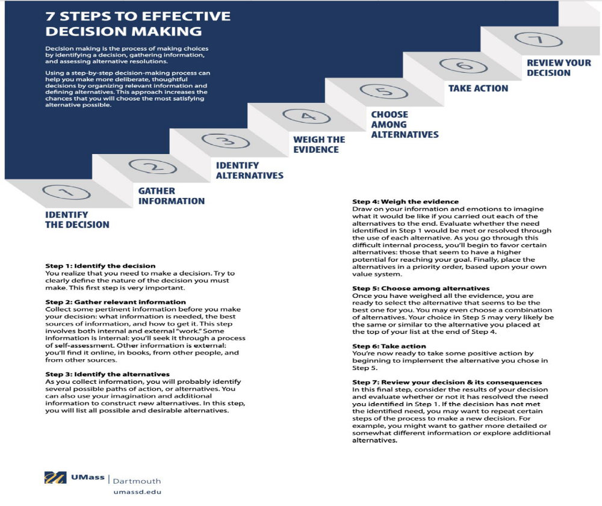
The Decision Support System (DSS) plays a crucial role in implementing a new corporate strategy for a multinational corporation. Let's break down how the DSS supports each step of the decision-making process:

1. **Identify the Decision:**
- DSS Application: Analyzes market trends, competitor strategies, and internal performance metrics to define the nature of the decision.

2. **Gather Relevant Information:**
- DSS Application: Aggregates data from market research reports, financial performance data, and industry forecasts to provide a comprehensive dataset for analysis.

3. **Identify Alternatives:**
- DSS Application: Utilizes predictive modeling and scenario analysis to generate multiple strategic alternatives based on different market conditions and company capabilities.

4. **Weigh the Evidence:**
- DSS Application: Applies multi-criteria decision analysis to evaluate the potential impact of each alternative, considering factors like cost, risk, and expected return.

5. **Choose Among Alternatives:**
- DSS Application: Presents a decision matrix summarizing the analysis, aiding decision-makers in selecting the most viable strategic option or a combination of strategies.

6. **Take Action:**
- DSS Application: Breaks down the chosen strategy into actionable tasks and projects, providing project management tools to guide implementation effectively.

7. **Review Your Decision:**
- DSS Application: Monitors the outcomes of the implemented strategy, offering reports on key performance indicators and suggesting adjustments if necessary.

In summary, the DSS serves as an essential tool throughout the decision-making process, enhancing the quality and efficiency of decisions by providing data-driven insights and analysis.

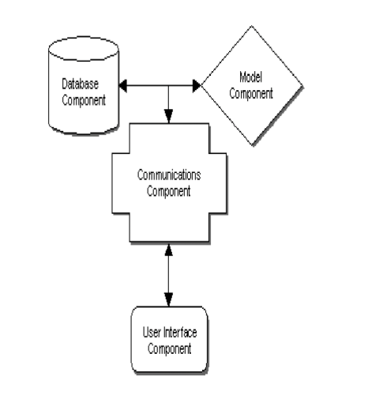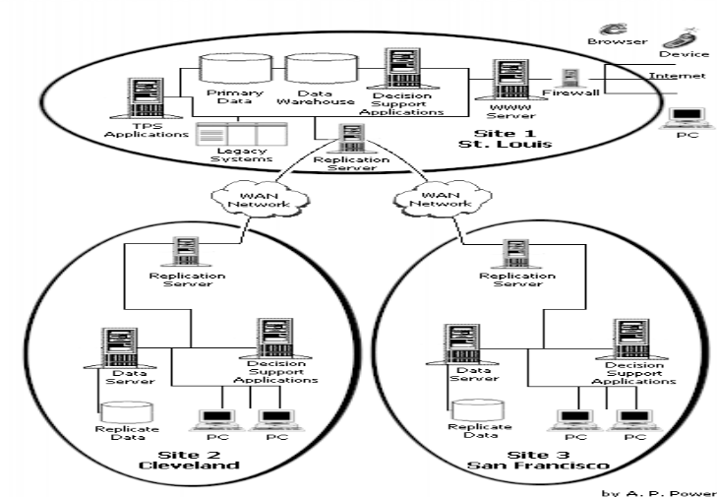
`
DSS Component | Significance | Role in Decision-Making | Interrelation and Impact
User Interface | Facilitates user interaction with the DSS, making it user-friendly and accessible. | Acts as the gateway for users to input data, run analyses, and view results, improving decision-making efficiency. | Directly impacts user adoption and effectiveness by providing a seamless interface for interaction with other DSS components.
Database | Serves as the repository for storing and managing vast amounts of data essential for informed decision-making. | Provides raw data for analysis, including historical, current, and predictive data models. | Supports models and analytical tools by supplying necessary data, ensuring decisions are based on accurate and up-to-date information.
Models and Analytical Tools | Comprises algorithms, statistical models, and computational tools that process and analyze data to generate insights and recommendations. | Transforms raw data into actionable insights, enabling evaluation of different scenarios. | Relies on data from the database and user inputs via the interface to perform analyses, with results often presented back through the interface.
Network | Ensures seamless communication and data exchange within the DSS infrastructure, connecting various components and users. | Enables collaborative decision-making, real-time data updates, and integration with other systems. | Facilitates data flow between components, ensuring synchronization and distributed decision-making.

Designing a scalable and secure DSS architecture for a multinational corporation involves integrating various DSS types while ensuring robust data management and networking:
Design Aspect | Consideration | Implementation Strategy
Data-Driven DSS | Focus on managing large data volumes from diverse global sources. | Implement cloud storage solutions with scalable databases and employ data warehousing techniques.
Model-Driven DSS | Ensure the system can handle complex computational models for various business scenarios. | Use modular design principles to allow easy integration of new models and update existing ones.
Knowledge-Driven DSS | Incorporate AI and machine learning for better decision-making insights. | Integrate knowledge management systems to continuously update and refine decision-making criteria.
Networking | Support secure and efficient data exchange across global locations. | Implement secure VPNs, use encryption for data in transit, and adopt reliable networking protocols like TCP/IP.
Data Management | Ensure data integrity, availability, and security across all operations. | Employ robust data governance frameworks, regular audits, and compliance with international data protection regulations.
Potential security threats to a DSS and outlining a comprehensive security strategy:
Security Threat | Impact on DSS | Technological Safeguards | Human-Centered Safeguards
Unauthorized Access | Data breaches and misuse of sensitive information. | Strong authentication mechanisms and access controls. | Regular security training and awareness programs.
Data Interception | Compromised confidentiality of decision-making processes. | Data encryption in transit and at rest using robust standards. | Education on secure data handling and transmission practices.
Malware Attacks | Data corruption, system disruption, and backdoor access. | Anti-malware software and intrusion detection systems. | Caution with email attachments and downloads from unknown sources.
Insider Threats | Malicious or unintentional data leaks or manipulation. | Data leakage prevention tools and user activity monitoring. | Foster a culture of security and ethical behavior, and implement strict data handling policies.
Social Engineering | Tricking users into divulging confidential information. | Multi-factor authentication and secure communication channels. | Training on recognizing and responding to social engineering tactics.
TCP/IP protocols influence DSS design and functionality:
Aspect | Influence of TCP/IP | Implications
Interoperability | Facilitates communication across diverse networks and systems. | Enhances integration within varied IT environments, improving data exchange.
Data Communication | Ensures reliable data transmission between DSS components. | Improves reliability and efficiency crucial for real-time decision-making.
Aspect | Role in DSS | Enhancement | Limitation
Performance | Manages tasks between servers and clients, distributing workload. | Improves by offloading heavy processing to powerful servers. | Limited by network latency and server bottlenecks.
Scalability | Allows addition of more servers or clients without major changes. | Facilitates growth by enabling modular expansion of resources. | Requires careful planning to avoid performance degradation.
Security | Defines clear boundaries between client and server roles. | Centralizes security controls on the server, simplifying management. | Relies heavily on network security, exposing vulnerabilities.
The role of client/server architecture in DSS:
Strategies for ensuring DSS relevance, security, and efficiency amidst technological advancements:
Strategy | Description
Modular Design | Develop DSS with interchangeable modules for easy updates and integration.
Continuous Learning | Invest in ongoing training for staff to stay updated on emerging technologies.
Security Protocols | Implement and update robust security measures to protect against cyber threats.
Data Management | Adopt advanced practices for scalability, reliability, and accessibility of data.
Innovation Culture | Foster a culture that encourages experimentation and adaptation of new tech.
Partnerships | Collaborate with tech firms and research institutions for insights into trends.

**Multiple Choice Questions:**

1. **What is the primary function of the user interface in a DSS?**
- A) To store data
- B) To facilitate user interaction with the system
- C) To analyze data
- D) To ensure data security
- Answer: B

2. **What role does the database play in a Decision Support System?**
- A) Data encryption
- B) Data analysis
- C) Data storage and management
- D) User authentication
- Answer: C

3. **Which of the following best describes the models and analytical tools in a DSS?**
- A) They ensure secure data transmission
- B) They facilitate user interaction
- C) They process and analyze data to generate insights
- D) They manage user permissions
- Answer: C

4. **The network component in a DSS is responsible for what?**
- A) Data storage
- B) User interface design
- C) Seamless communication and data exchange
- D) Data analysis
- Answer: C

5. **How does modular design benefit a DSS architecture?**
- A) By reducing data storage needs
- B) By facilitating easy updates and integration of new technologies
- C) By simplifying the user interface
- D) By enhancing data encryption methods
- Answer: B

6. **Continuous learning in the context of DSS primarily ensures what?**
- A) Data is encrypted
- B) Staff stay abreast of emerging technologies
- C) Data storage costs are minimized
- D) The user interface is intuitive
- Answer: B

7. **What is the purpose of implementing security protocols in a DSS?**
- A) To enhance data analysis capabilities
- B) To improve the user interface
- C) To protect against evolving cyber threats
- D) To reduce data storage requirements
- Answer: C

8. **The adoption of advanced data management practices in a DSS ensures what?**
- A) The system has a visually appealing interface
- B) Data scalability, reliability, and accessibility
- C) Reduction in training requirements for staff
- D) Decrease in network communication needs
- Answer: B

9.

**An innovation culture within an organization contributes to a DSS by doing what?**
- A) Reducing the amount of data stored
- B) Encouraging experimentation and adaptation of new technologies
- C) Simplifying the network infrastructure
- D) Decreasing the need for data analysis
- Answer: B

10. **How do partnerships with tech firms and research institutions benefit a DSS?**
- A) By providing insights into cutting-edge technologies
- B) By reducing the need for a user interface
- C) By minimizing data storage needs
- D) By eliminating the need for network components
- Answer: A

11. **In a DSS, data-driven decision-making primarily relies on what component?**
- A) User interface
- B) Database
- C) Network
- D) Models and analytical tools
- Answer: B

12. **The primary purpose of AI and machine learning in a model-driven DSS is to:**
- A) Reduce data storage costs
- B) Improve data security
- C) Enhance data encryption
- D) Provide better decision-making insights
- Answer: D

13. **What is a key benefit of using secure VPNs in a DSS network?**
- A) To increase data storage capacity
- B) To improve the aesthetics of the user interface
- C) To ensure secure and efficient data exchange
- D) To reduce the reliance on models and analytical tools
- Answer: C

14. **The primary challenge of data interception in a DSS is:**
- A) Increased data storage costs
- B) Compromised decision-making confidentiality
- C) Overloading the user interface
- D) Reducing network communication speed
- Answer: B

15. **What does the use of multi-factor authentication in a DSS primarily address?**
- A) Enhancing the visual appeal of the user interface
- B) Increasing data storage efficiency
- C) Preventing unauthorized access
- D) Reducing the need for analytical models
- Answer: C

16. **How does TCP/IP influence the design of a DSS?**
- A) By determining the color scheme of the user interface
- B) By influencing interoperability and data communication
- C) By reducing the effectiveness of models and analytical tools
- D) By increasing data storage requirements
- Answer: B

17. **The implementation of robust data governance frameworks in a DSS aims to:**
- A) Decorate the user interface
- B) Ensure data integrity, availability, and security
- C) Reduce the need for network components
- D) Eliminate the use of models and analytical tools
- Answer: B

18. **What is the impact of malware attacks on a DSS?**
- A) They enhance the functionality of models and analytical tools
- B) They improve the efficiency of data storage
- C) They can corrupt data and disrupt system operations
- D) They make the user interface more intuitive
- Answer: C

19. **The role of data leakage prevention tools in a DSS is to:**
- A) Make the network communication faster
- B) Enhance the visual elements of the user interface
- C) Prevent unauthorized disclosure of sensitive information
- D) Reduce the reliance on statistical models
- Answer: C

20. **How does client/server architecture enhance the scalability of a DSS?**
- A) By simplifying the user interface
- B) By allowing the addition of more servers or clients without major changes
- C) By reducing the effectiveness of analytical tools
- D) By decreasing data storage needs
- Answer: B

